Terraform to install aws services

1. First we have to create AWS account, github account
2. Install VScode, aws cli, github and terraform to windows
3. Map aws access key and secret key to windows
4. Create provider.tf in vs code

1. Then create file to create s3 bucket from terraform in AWS

1. Create repository in github to push terraform code

1. In VScode terminal command type -> terraform init
2. -> terraform plan
3. -> terraform apply
4. -> yes
5. -> git init
6. -> it remote add origin <https://github.com/git2srini/terraform.git>
7. -> git branch -M main
8. -> git add .
9. -> git commit -m "Initial commit: terraform_s3"
10. -> git push -u origin main
11. We can see the code in github

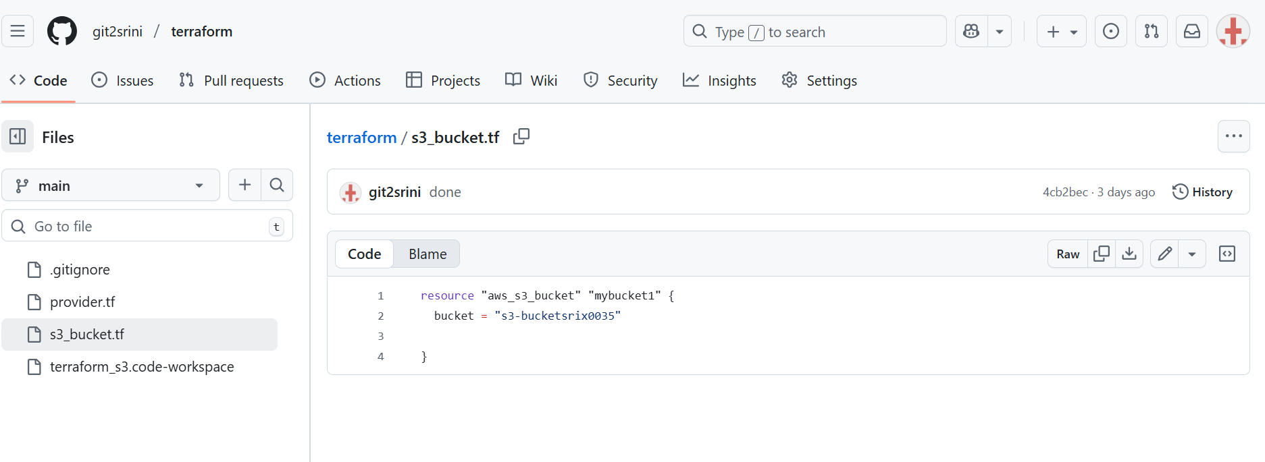

Creation of Ec2

Create the file aws_ec2.tf

resource "aws_instance" "free_ec2" {

  ami           = "ami-0c02fb55956c7d316" # Amazon Linux 2 AMI (us-east-1 free-tier)

  instance_type = "t2.micro"              # Free-tier eligible

  tags = {

    Name = "FreeTier-EC2"

  }

}

# Manage its power state separately

resource "aws_ec2_instance_state" "stop_instance" {

  instance_id = "i-01c978316051df228"

  state       = "stopped"   # can be "running" or "stopped"

}

Then run

Terraform plan

Terraform apply

yes

